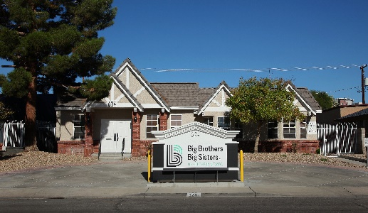  DOWNTOWN LAS VEGAS  Monday to Friday  9:00 AM to 5:00 PM  624 S. 10th Street  Las Vegas, NV 89101  **This location is our Southern Nevada corporate office. A donation tax receipt is available at this location. | 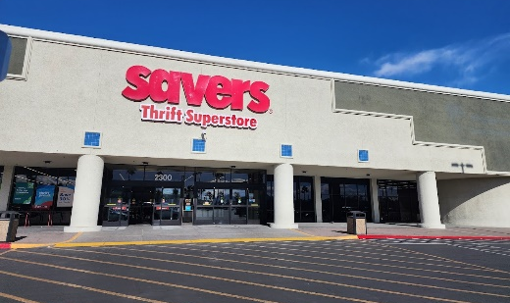  SAVERS TROPICANA  Monday to Saturday  10:00 AM to 8:00 PM  Sunday  10:00 AM to 7:00 PM  2300 E. Tropicana Avenue  Las Vegas, NV 89119  **This donation center is owned and operated on our behalf by Savers. A donation tax receipt is available at this location. | 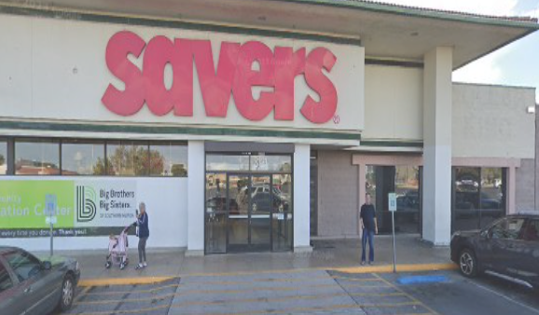  SAVERS RANCHO  Monday to Saturday  10:00 AM to 8:00 PM  Sunday  10:00 AM to 7:00 PM  3121 N. Rancho Drive  Las Vegas, NV 89130  **This donation center is owned and operated on our behalf by Savers. A donation tax receipt is available at this location.
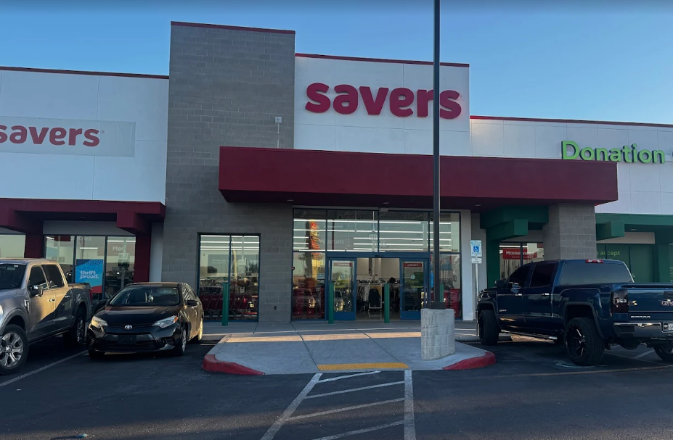  SAVERS BLUE DIAMOND  Monday to Saturday  9:00 AM to 8:00 PM  Sunday  10:00 AM to 8:00 PM  3835 Blue Diamond Road  Las Vegas, NV 89139  **This donation center is owned and operated on our behalf by Savers. A donation tax receipt is available at this location. | 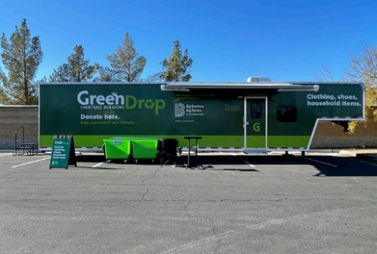  SHADOW MOUNTAIN  Monday to Sunday  8:30 AM to 5:00 PM  6415 N. Decatur Blvd.  Las Vegas, NV 89131  Look for the Green Drop trailer in the lot between Ashley Furniture & Costco. | 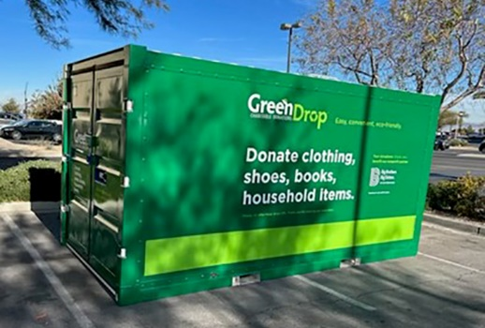  GREEN VALLEY CROSSING (NOW OPEN - FORMERLY DONATION DROP SPOT)  Monday to Sunday  8:30 AM to 5:00 PM  645 S. Green Valley Parkway  Henderson, NV 89052  Located off Green Valley Parkway, south of Walgreens in front of Sprouts.
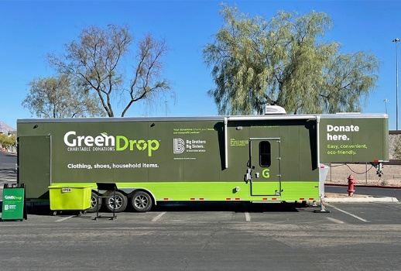  TROPICANA  Monday to Sunday  8:30 AM to 5:00 PM  5010 S. Fort Apache Road  Las Vegas, NV 89148  Located in the parking lot between Lowe's Home Improvement and Me 'n Mommy To Be. | 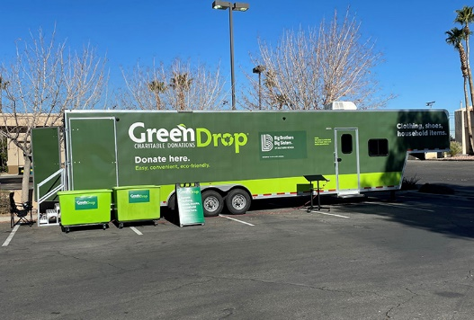  EASTERN SPRINGS VILLAGE  Monday to Sunday  8:30 AM to 5:00 PM  7435 S. Eastern Avenue  Las Vegas, NV 89123  Located in the lot near Walmart by the carwash. | 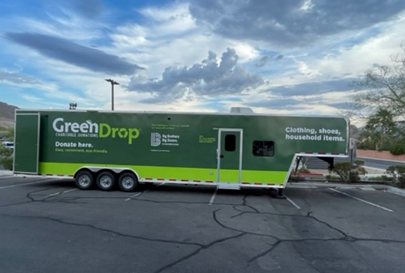  SHADOW HILLS  Monday to Sunday  8:30 AM to 5:00 PM  10420 W. Cheyenne Avenue  Las Vegas, NV 89129  Located in Shadow Hills Plaza by Walmart and Wells Fargo.

